BRASS Liquidity Services OMSD FIX Interface Specification

Revision 1.0.10

June 12, 2008

- Introduction to BRASS Liquidity Services OMSD FIX Gateway

BRASS Liquidity Services OMSD FIX Gateway accepts FIX 4.1 protocol. It will listen to a port, accepting incoming FIX messages from clients, then converting FIX message into OMSD internal messages and route into central OMSD system. When it receives updates from central OMSD system, it will then translate the message from OMSD internal messages into FIX message and send them to clients.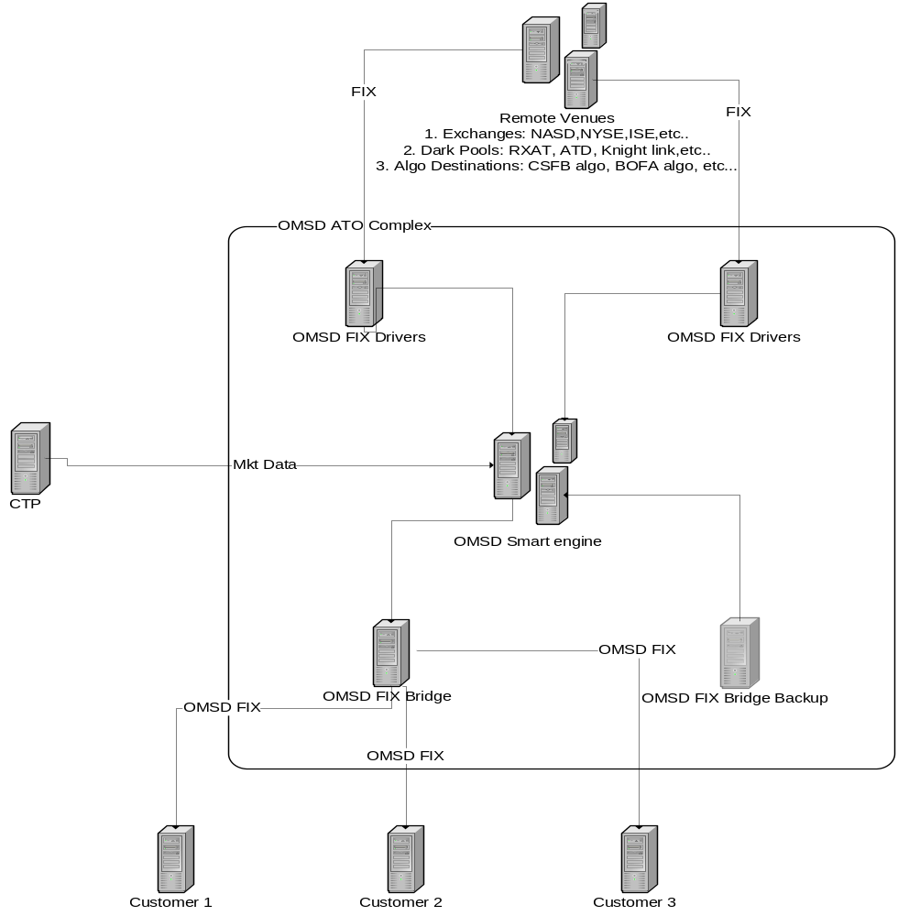

- Session Information

First message should be a logon message. Client should not transmit additional messages until OMSD verifies SenderCompID(tag49) and sends back logon response.

Note: SenderCompID(tag 49) is an 8 character string assigned by OMSD FIX gateway prior to connection.

- Session Protocol Messages

OMSD FIX gateway conforms to FIX4.1 standard in handling administrative messages such as heartbeat, resend request, sequence reset…

Please refer to standard FIX4.1 protocol document.

Also, OMSD FIX gateway utilizes customized tags and some standard tags in FIX4.2 and later versions.

Standard Message Header

Tag | Field Name | Req'd | Comments and/or Supported Values
8 | BeginString | Y | ALWAYS FIRST FIELD IN MESSAGE, must be “FIX.4.1”
9 | BodyLength | Y | Message length, in bytes, forward to the CheckSum field. ALWAYS SECOND FIELD IN MESSAGE.
35 | MsgType | Y | Defines message type. ALWAYS THIRD FIELD IN MESSAGE.  Valid Value(s):  0 = Heartbeat  1 = Test Request  2 = Resend Request  3 = Reject  4 = Reset Sequence  5 = Logout  8 = Execution Report  9 = Order Cancel Reject  A = Logon  D = New Order Single  F = Order Cancel  G = Order Cancel/Replace
49 | SenderCompId | Y | Assigned by OMSD prior to connection.
34 | MsgSeqNo | Y | Integer message sequence number.
52 | SendingTime | Y | Time of message transmission (always expressed in GMT)
43 | PossDupFlag | N | Indicates possible retransmission of message with this sequence number.  N = Original transmission  Y = Possible duplicate
97 | PossResend | N | Indicates that message may contain information that has been sent under another sequence number. Required when message may be duplicate of another message sent under a different sequence number.
122 | OriginalSendingTime | N | Original time of message transmission (always expressed in GMT) when transmitting orders as the result of a resend request. Required for message resends.

Standard Message Trailer
The Standard Message Trailer is required on all messages, and must be the LAST part of the message.

Tag | Field Name | Req'd | Comments and/or Supported Values
10 | CheckSum | Y | Three byte checksum. Always last field in message.

Logon
The Logon message is utilized to authenticate a user attempting to establish a connection to a remote system. The logon message must be the first message sent by the application requesting to initiate a FIX session.

Tag | Field Name | Req'd | Comments and/or Supported Values
 | Standard Header | Y | MsgType = A
98 | EncryptMethod | Y | Not Supported (Always unencrypted)
108 | HeartBtInt | Y | Heartbeat interval (seconds)
 | Standard Trailer | Y

Test Request
The Test Request message is utilized to force a heartbeat from the opposing application. The test request message is useful for checking sequence numbers or verifying communication line status. The opposite application will respond to the Test Request with a Heartbeat containing the TestReqID.

Tag | Field Name | Req'd | Comments and/or Supported Values
 | Standard Header | Y | MsgType = 1
112 | TestReqID | Y | Identifier included in Test Request message to be returned in resulting Heartbeat
 | Standard Trailer | Y

Heartbeat
The Heartbeat is useful for monitoring the status of the communication link to identify when the last string of messages was not received.

Tag | Field Name | Req'd | Comments
 | Standard Header | Y | MsgType = 0
112 | TestReqID | N | Required when the heartbeat is the result of a Test Request message.
 | Standard Trailer | Y

Resend Request
The Resend Request is sent by the receiving application to initiate the retransmission of message(s). This function is utilized if a sequence number gap it detected, if the receiving application lost a message, or as a function of the initialization process.
The Resend Request can be used to request a single message, a range of messages or all messages subsequent to a particular message.

Tag | Field Name | Req'd | Comments
 | Standard Header | Y | MsgType = 2
7 | BeginSeqNo | Y | Message sequence number of first record in range to be resent
16 | EndSeqNo | Y | Message sequence number of last record in range to be resent. If request is for a single record BeginSeqNo = EndSeqNo. If request is for all messages subsequent to a particular message, EndSeqNo = "999999"
 | Standard Trailer | Y

Reject
The Reject message should be used when a message is received which cannot be passed through to the application level. An example of when a reject may be appropriate would be the receipt of a message with invalid basic data (e.g., MsgType=&) which successfully passes de-encryption, CheckSum and BodyLength checks. (As a rule, messages should be forwarded to the trading application for business level rejects whenever possible).

Tag | Field Name | Req'd | Comments
 | Standard Header | Y | MsgType = 3
45 | RefSeqNo | Y | MsgSeqNum of rejected message
58 | Text | N | Where possible, message to explain reason for rejection
 | Standard Trailer | Y

Sequence Reset
The Sequence Reset message is used by the sending application to reset the incoming sequence number on the opposing side. The sending application will initiate the sequence reset. The message is used to reset the value of the next sequence number to be transmitted.

Tag | Field Name | Req'd | Comments
 | Standard Header | Y | MsgType = 4
123 | GapFillFlag | N | Indicates that the Sequence Reset message is replacing administrative or application messages which will not be resent.  Valid values:  Y = Gap Fill message, MsgSeqNum field valid  N = Sequence Reset, ignore MsgSeqNum
36 | NewSeqNum | Y | New sequence number  Valid values:  0 - 999999
 | Standard Trailer | Y

Logout
The Logout message is used to initiate or confirm the termination of a FIX session. Disconnection without the exchange of logout messages should be interpreted as an abnormal condition.

Tag | Field Name | Req'd | Comments
 | Standard Header | Y | MsgType = 5
58 | Text | N | Free format text string
 | Standard Trailer | Y

- Inbound messages to OMSD

Note: Additional tags may be added in the future.

New Order

Tag | Field Name | Req'd | Comments
 | Standard Header | Y | MsgType = D
11 | ClOrdID | Y | Unique identifier for Order as assigned by institution. Uniqueness must be guaranteed within a single trading day.  The max length is 24 bytes.  At this stage, OMSD gateway does not support multi-day order.
21 | HandlInst | Y | Instructions for order handling on Broker trading floor  Valid values:  1 = Automated execution order, private, no Broker intervention
18 | ExecInst | N | Can contain multiple instructions, space delimited  ‘f’ = ISO order flag
111 | MaxFloor | N | Maximum number of shares within an order to be shown at any given time. The presence of this field allows the sender to choose the display quantity of their order.
100 | ExDestination | Y | Intended destination, valid values:  ‘ATO’ = Internal OMSD destination  ‘INET’ = Routed to NASDAQ  ‘ARCA’ = Routed to NYSE ARCA  ‘NYSE’ = Routed to NYSE  ‘AMEX’ = Routed to AMEX  ‘CHXX’ = Routed to Chicago Exchange  ‘CBOE’ = Routed to Chicago Board of Options  ‘ISE’ = Routed to ISE Exchange  ‘ATTN’ = Routed to EDGA  ‘NOCI’ = Routed to EDGX  ‘BTRD’ = Routed to Bloomberg  ‘TRAC’ = Routed to TRAC  ‘BATS’ = Routed to BATS  ‘NSX’ = Routed to National Exchange  ‘PHLX’ = Routed Philadelphia Exchange  ‘LAFL’ = Routed to LavaFlow  ‘ATM’ = Routed to ATM algo destination
76 | Exec Broker | N | Routing Instruction.  The following is through ISO, must be IOC and have ‘f’ in tag 17, and tag 100 in (‘INET’)  ISAM = ISO routed to AMEX  ISPA = ISO routed to ARCA  ISBX = ISO routed to BOSX  ISCB = ISO routed to CBOE  ISCX = ISO routed to CHXX  ISCN = ISO routed to NSX  ISGA = ISO routed to EDGA  ISGX = ISO routed to EDGX  ISIS = ISO routed to ISE  ISLF = ISO routed to LavaFlow  ISNQ = ISO routed to Nasdaq  ISNY = ISO routed to NYSE  ISPX = ISO routed to PHLX  ISTR = ISO routed to TRAC
55 | Symbol | Y | Ticker Symbol
65 | SymbolSfx | N | Additional information about the security (e.g. preferred, warrants, etc.). Absence of this field indicates common.  Valid values:  As defined in the NYSE Stock and bond Symbol Directory and in the AMEX Fitch Directory
54 | Side | Y | Side of order  Valid values:  1 = Buy  2 = Sell  5 = Sell short
38 | OrderQty | Y | Number of shares ordered  Valid values:  (0 - 1000000000)
40 | OrdType | Y | Order type.  Valid values:  1 = Market  2 = Limit
44 | Price | N | Price per share. Required for limit OrdTypes.  Valid values:  0 - 99999999.9999
59 | TimeInForce | N | Specifies how long the order remains in effect. Absence of this field is interpreted as DAY.  Valid values:  0 = Day  3 = IOC (not applicable when exDestination = ‘ATO’)  5 = GTX  6 = Good Till Date (ExpireTime is required)
168 | Start Time | N | Effective start time of order (always expressed in GMT).
126 | ExpireTime | N | Time/Date of order expiration (always expressed in GMT).
47 | Rule80A | N | Indicates order type upon which exchange Rule 80A is applied.  Valid values:  A = Agency  P = Principal
11018 | Execution Type | N | When ExDestination = ‘ATO’, allows  ‘VWAP’ - basic VWAP strategy  ‘TWAP’ - basic TWAP strategy  ‘PING’ – flashlight to ping available dark pools  ‘POST’ – for limit order, post balance to a venue after market sweep, requires 11023.  ‘WTB’ – for limit order, once market price is out of reach for this order, reject order back to client
11019 | Traded Quantity Trigger | N | Required if 11018 is ‘TWAP’  Indicates how many shares have been traded before sending next slice.
11020 | Slice Interval | N | In TWAP, it indicates when to send the next slice after slice interval (in seconds) passes (either 11020 or 11021 must be present, 11021 will override 11020)  In VWAP, it indicates when to send the next slice after slice interval (in seconds) passes and yet during that period of time, volume does not pass traded quantity trigger
11021 | Number of Slices | N | Indicates how many slices to create  In TWAP, either 11020 or 11021 must be present, 11021 will override 11020.  In VWAP, it is required.
11022 | Algo Special Tags | N | algo tag container for possible corresponding algo destinations tags.  The format for this tag is same as normal FIX messages, except that you should use ‘,’ as field separator instead of ‘\001’.  For example, the following is a possible string value for tag 11022  99980=2,99970=TEST,  99980 and 99970 are corresponding algo destination tags.
11023 | Post Destination | N | Indicate the venue to post the balance.  Similar values to tag 100.  Required when 11018=”POST”
58 | Text | N | Free format text string.
 | Standard Trailer | Y

Cancel Request
The order cancel request cancels all of the remaining quantity of an existing order.

Tag | Field Name | Req'd | Comments
 | Standard Header | Y | MsgType = F
41 | OrigClOrdID | Y | ClOrdID of the previous order (NOT the initial order of the day) when canceling or replacing an order.
37 | OrderID | N | Unique identifier of most recent order as assigned by OMSD.
11 | ClOrdID | Y | Unique ID of cancel request as assigned by the institution.
55 | Symbol | Y
65 | SymbolSfx | N
54 | Side | Y
58 | Text | N
 | Standard Trailer | Y

Cancel Replace Request

Cancel Replace is implemented by canceling the original order and then entering the remaining leave Qty as new order. The new order carries the cumQty of previous order.

Tag | Field Name | Req'd | Comments
 | Standard Header | Y | MsgType = G
37 | OrderID | N | Unique identifier of most recent order as assigned by OMSD.
41 | OrigClOrdID | Y | ClOrdID of the previous order (NOT the initial order of the day) when canceling or replacing an order.
11 | ClOrdID | Y | Unique identifier of replacement order as assigned by institution. Note that this identifier will be used in ClOrdID field of the Cancel Reject Message if the replacement request is rejected.
100 | ExDestination | Y | Execution destination as defined by institution when order is entered. Must be same as previous order.
18 | ExecInst | N | Can contain multiple instructions, space delimited
54 | Side | Y | Must match original side, however, Buy and Buy Minus can be interchanged as well as Sell and Sell Plus
38 | OrderQty | Y | Order quantity
40 | OrdType | Y
44 | Price | N | Price per share. Required for limit OrdTypes.  Valid values:  0 - 99999999.9999
59 | TimeInForce | N | Absence of this field indicates to use existing order’s value
168 | Start Time | N | Effective start time of order (always expressed in GMT).
126 | ExpireTime | N | Time/Date of order expiration (always expressed in GMT).
11018 | Execution Type | N
11019 | Traded Quantity Trigger | N | Required if 11018 is ‘VWAP’  Indicates how many shares have been traded before sending next slice.
11020 | Slice Interval | N | In TWAP, it indicates when to send the next slice after slice interval (in seconds) passes (either 11020 or 11021 must be present, 11021 will override 11020)  In VWAP, it indicates when to send the next slice after slice interval (in seconds) passes and yet during that period of time, volume does not pass traded quantity trigger
11021 | Number of Slices | N | Indicates how many slices to create  In TWAP, either 11020 or 11021 must be present, 11021 will override 11020.  In VWAP, it is required.
11022 | Algo Special Tags | N | algo tag container for possible corresponding algo destinations tags.  The format for this tag is same as normal FIX messages, except that you should use ‘,’ as field separator instead of ‘\001’.  For example, the following is a possible string value for tag 11022  99980=2,99970=TEST,  99980 and 99970 are corresponding algo destination tags.
11023 | Post Destination | N | Indicate the venue to post the balance.  Required when 11018=”POST”
58 | Text | N
 | Standard Trailer | Y

- Outbound messages from OMSD

Note: Additional tags may be added in the future.

Execution Report

Tag | Field Name | Req'd | Comments
 | Standard Header | Y | MsgType = 8
37 | OrderID | Y | Unique identifier for Order as assigned by OMSD. Uniqueness is guaranteed within a single trading day.
11 | ClOrdID | Y | Unique identifier for Order as assigned by institution. Uniqueness must be guaranteed within a single trading day.
17 | ExecID | Y | Unique identifier of execution message as assigned by OMSD.
20 | ExecTransType | Y | Identifies transaction type  Valid values:  0 = New  1 = Cancel  2 = Correct
19 | ExecRefID | N | Required for Cancel and Correct ExecTransType messages
150 | ExecType | Y | Describes the specific ExecutionRpt (i.e. Pending Cancel) while OrdStatus will always identify the current order status (i.e. Partially Filled)  Valid Values are the same as OrdStatus.
39 | OrdStatus | Y | Identifies current status of order.  Valid values:  0 = New  1 = Partially filled  2 = Filled  4 = Canceled  5 = Replaced  8 = Rejected  C = Expired
55 | Symbol | Y | Ticker Symbol
65 | SymbolSfx | N | Additional information about the security (e.g. preferred, warrants, etc.). Absence of this field indicates common.
54 | Side | Y | Side of order  Valid values:  1 = Buy  2 = Sell  5 = Sell short
38 | OrderQty | Y | Number of shares ordered  Valid values:  (0 - 1000000000)
40 | OrdType | N | Order type.  Valid values:  1 = Market  2 = Limit
44 | Price | N | Price per share  Valid values:  0 - 99999999.9999
47 | Rule80A | N | Indicates order type upon which exchange Rule 80A is applied.  Valid values:  A = Agency  P = Principal
32 | LastShares | Y | Quantity of shares bought/sold on this fill.
31 | LastPx | Y | Price of last fill.
14 | CumQty | Y | Total number of shares filled.  Valid values:  (0 - 1000000000)
151 | LeavesQty | Y | Total number of shares remain open  Valid values:  (0 - 1000000000)
60 | TransactTime | N | Time of execution/order creation (expressed in GMT)
100 | ExDestination | Y | Execution destination , same as when order is entered.
11015 | Venue Order Id | N | Remote Venue Order ID if available
11016 | Venue Exec Id | N | Remote Venue trade reference number if available
11017 | Venue Ident | N | Remote Venue identification if there is a trade.  You will receive “DKPL” for dark pool trades.
58 | Text | Y | Free format text string.
 | Standard Trailer | Y

Order Cancel Reject

Tag | Field Name | Req'd | Comments
 | Standard Header | Y | MsgType = 9
37 | OrderID | Y | Unique identifier for Order as assigned by OMSD. Uniqueness is guaranteed within a single trading day.
11 | ClOrdID | Y | Unique identifier for Order as assigned by institution. Uniqueness must be guaranteed within a single trading day.
41 | OrigClOrdID | Y
39 | OrderStatus | Y | OrderStatus value after this cancel reject is applied
102 | CxlRejReason | N | Code to identify reason for cancel rejection.  Valid values:  0 = Too late to cancel  1 = Unknown order
58 | Text | Y | Free format text string.
 | Standard Trailer | Y

Appendix A, Customized Tag

Tag | Field Name | Req'd | Comments
11015 | Venue Order Id | N | Remote Venue Order ID if available
11016 | Venue Exec Id | N | Remote Venue trade reference number if available
11017 | Venue Ident | N | Remote Venue identification if there is a trade, possible values are same as those in ExDestination field.  You will receive “DKPL” for dark pool trades.
11018 | Execution Type | N | When ExDestination = ‘ATO’, allows  ‘VWAP’ - basic VWAP strategy  ‘TWAP’ - basic TWAP strategy  ‘PING’ – flashlight to ping available dark pools  ‘POST’ – for limit order, post balance to a venue after market sweep, requires 11023.  ‘WTB’ – for limit order, once market price is out of reach for this order, reject order back to client
11019 | Traded Quantity Trigger | N | Required if 11018 is ‘TWAP’  Indicates how many shares have been traded before sending next slice.
11021 | Number of Slices | N | Indicates how many slices to create  In TWAP, either 11020 or 11021 must be present, 11021 will override 11020.  In VWAP, it is required.
11022 | Algo Special Tags | N | algo tag container for possible corresponding algo destinations tags.  The format for this tag is same as normal FIX messages, except that you should use ‘,’ as field separator instead of ‘\001’.  For example, the following is a possible string value for tag 11022  99980=2,99970=TEST,  99980 and 99970 are corresponding algo destination tags.
11023 | Post Destination | N | Indicate the venue to post the balance.  Similar values to tag 100.  Required when 11018=”POST”

Appendix B, Sample FIX messages

NewOrderSingle

8=FIX.4.19=17335=D49=LUOKUN34=2752=20080612-15:16:4411=TESTC8734EC1Z21=1100=INET55=ZVZZT54=138=100040=244=10059=047=P9140=A9355=O10=063

Execution Report (Order Acknowledgement)

8=FIX.4.19=18735=856=LUOKUN34=2752=20080612-15:16:4537=TEST72400001YZ11=TESTC8734EC1Z17=020=0150=039=055=ZVZZT54=138=100040=244=10059=032=031=0151=100014=0100=INET11015=REFERENCE210=222

Execution Report (Partial Execution)

8=FIX.4.19=23735=856=LUOKUN34=2852=20080612-15:16:4537=TEST72400001YZ11=TESTC8734EC1Z17=TEST72400001YZ_48513ddd:320=0150=139=155=ZVZZT54=138=100040=244=10032=4031=101151=96014=40100=INET11015=REFERENCE211016=48513ddd:311017=INET10=047

Cancel Request

8=FIX.4.19=15935=F49=LUOKUN34=3352=20080612-15:21:5341=TESTC8734EC1Z37=TEST72400001YZ11=TESTC8734EC1Z5109=TEST55=ZVZZT54=138=100010=043

Execution Report (Canceled)

8=FIX.4.19=17635=856=LUOKUN34=3752=20080612-15:21:5437=TEST72400001YZ11=TESTC8734EC1Z17=020=0150=439=455=ZVZZT54=138=100040=244=10059=0151=014=300100=INET11015=REFERENCE210=014

Cancel Replace Request

8=FIX.4.19=17435=G49=LUOKUN34=3952=20080612-15:25:3541=TESTC8734ECBZ11=TESTC8734ECEZ21=155=ZVZZT54=138=200040=244=10059=047=P9140=A10=255

Execution Report (Replaced)

8=FIX.4.19=19735=856=LUOKUN34=5152=20080612-15:25:3637=TEST72400004YZ11=TESTC8734ECEZ41=TESTC8734ECBZ17=020=0150=539=555=ZVZZT54=138=200040=244=10059=0151=170014=300100=INET11015=REFERENCE2910=002

Cancel Reject (Issue is incorrect value in tag 41 for cancel replace)

8=FIX.4.19=9035=956=LUOKUN34=8852=20080612-15:45:5411=TESTC8734EE0Z58=Unknown order TDSTC8734EDDZ10=217

Session Reject (Issue is no value in tag 100 for new order)

8=FIX.4.19=6135=356=LUOKUN34=9152=20080612-15:48:5745=6958=No ExDest10=109

